4v4 Rallyball Rules
Players not on the court must rotate into the game upon completion of the Tripleball sequence that follows their serve. For example: Player A serves the ball and stays on court for the following 2 free balls to complete the Tripleball sequence. Once that sequence is complete, Player A rotates out of the court and player B takes their place on the court.
All team members must play in each set. The only exception to this rule is if a team has more than 10 players on their roster, in which case they can be split into two groups who each participate in a single set. If the match goes to a third set tiebreaker, the coach can play one of the groups a second time in the match.
• Teams can use a diamond or square (2 front, 2 back) defensive formation. (See diagram below *click on 4v4 Rules button)
• Teams must designate the setter position and maintain it for the whole set. The designated setting position must be front row.
NOTE: The server is always the player who has just rotated from the front row to the back row.
Example in box formation: the player who was just in the front row right side position (#1 in the diagram below) will be the server once they complete a rotation.
Example in diamond formation: the player who was just in the front row middle (#2 in the diagram below) and is rotating to the position on the right is now the server.
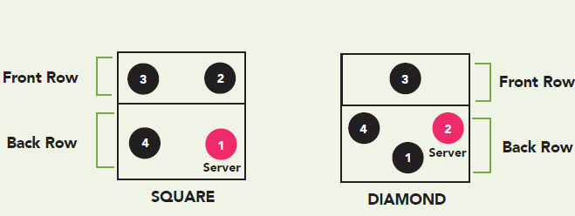
• The player(s) in the backcourt (serve receiver/server) are permitted to attack from anywhere on the court
Specialization Not Permitted
Warm Up Protocol
First match of the day:  8 min – shared court  4 min – exclusive serving team  4 min – exclusive receiving team | All remaining matches:  2 min – shared court  4 min – exclusive serving team  4 min – exclusive receiving team  No shared hitting or travelling under net
Medals: No medals until Ontario Championships
Athlete Membership Level
Recreational membership $12.91 – upgrade to a full competitive membership if the athlete is participating in 6v6 or TLS competitions
4v4 Rallyball Playing Regulations
• Players not on the court must rotate into the game upon completion of the Tripleball sequence that follows their serve. For example: Player A serves the ball and stays on court for the following 2 free balls to complete the Tripleball sequence. Once that sequence is complete, Player A rotates out of the court and player B takes their place on the court. • All team members must play in each set. The only exception to this rule is if a team has more than 10 players on their roster, in which case they can be split into two groups who each participate in a single set.
If the match goes to a third set tiebreaker, the coach can play one of the groups a second time in the match. • Systems of Play: Teams must designate the setter position and maintain it for the whole set. The designated setting position must be front row. The player(s) in the back court (serve receiver/server) are permitted to attack from anywhere on the court. Teams can use a diamond (1 front, 3 back row) or square (2 front, 2 back) defensive formation. NOTE: The server is always the player who has just rotated from the front row to the back row. ▪ Example in box formation: the player who was just in the front row right side position will be the server once they complete a rotation. ▪ Example in diamond formation: the player who was just in the front row middle (#3 in the diagram below) and is rotating to the position on the right is now the server.

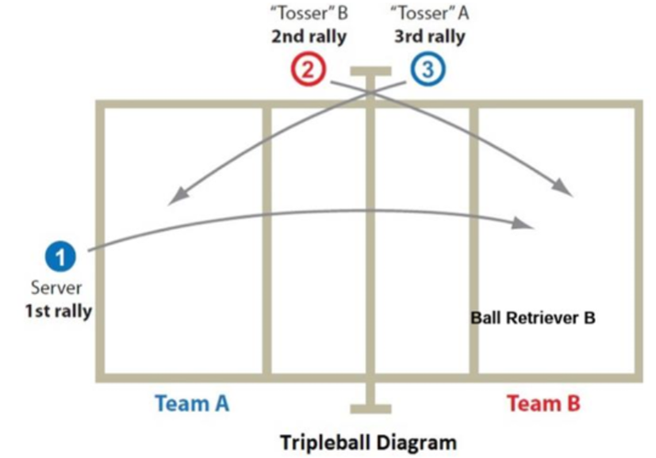
Overview of the Tripleball Sequence: a) The game follows a sequence of three rallies (service, tossed ball 1, tossed ball 2). * 1st rally – introduced by the server * 2nd rally – tossed ball given to the receiving team * 3rd rally – tossed ball given to the serving team b) The service rotates between teams after each three-ball sequence. c) A team must rotate and introduce a new server when it is their turn to serve. d) Every ball introduced is worth one point.

